Geoheritage promotion through an interactive exhibition: A case study from the Carnic Alps, NE Italy

Geoheritage - June 2019, Vol. 11, Issue 2, 459–469
Corrado Venturini1, Federico Pasquaré Mariotto2

1 Department of Biological, Geological and Environmental Sciences, Bologna University, Via Zamboni 67, Bologna 40126, Italy
2Department of Theoretical and Applied Sciences, Insubria University, Via Mazzini 5, 21100 Varese, Italy

Abstract
Museum exhibitions can be regarded as a key tool for communicating geoheritage. However, in many countries including Italy, the viewers’ experience is often negatively affected by the old-time style of interpretive panels: In most cases, panels are unattractive, graphically poor, and made user- unfriendly by the disproportionate amount of text in relation to the amount of illustrations.
This work analyzes the organization of a recent permanent geo-paleontological exhibition dedicated to geoheritage and geoscience communication in the Italian Alps. The exhibition uses a number of innovative strategies aimed at reversing the above trend. In particular, we discuss the ways in which interpretive panels were created, and highlight the strategies used to combine traditional popularization tools with innovative, multimedia and interactive exhibits.
We also delve into the role played by a balanced distribution of the topics across the exhibition: The contents need to be consequentially organized and illustrated through simple and intuitive explanations, thereby helping to reinforce the viewers’ perception that the topics they are exploring can be thoroughly understood, and ensure an adequate degree of information sustainability.

Keywords
Geoheritage; interpretive panel; multimedia; information sustainability; Carnic Alps; Pramollo

Introduction

Geoheritage, as defined and reviewed in seminal works by Brocx and Semenius (2007, 2010, 2011) and Thomas (2016), can be a key tool to raise awareness about the natural environment; through landscapes and outcrops, it can be used to communicate a story that renders accessible the concepts and advances of geoscience to the general public. Geoparks can also play a paramount role in this respect (de Grosbois and Eder 2008; Avila et al. 2016; Melinte-Dobrinescu et al. 2017).
Also geoscience museums may be regarded as key to accomplishing the goals of geoheritage popularization and protection (Reis et al. 2014; Pasquaré Mariotto and Venturini 2017). In keeping with the latter purpose, in 2015 the Municipality of Pontebba (County of Udine), a small town in the NE of Italy near the Pramollo Pass, which connects Italy and Austria, opened up a permanent exhibition, titled When Pramollo was at the Equator. The subtitle, A 3D voyage into the Carnic Alps of 300 million years ago, is aimed at clarifying the exhibition’s main goal: Valorizing and promoting the outstanding geological heritage across the 80-square-km-wide alpine area near the Pramollo Pass (Nassfeld Pass), straddling the border between Italy and Austria.
The peculiarity of this sector of the Alps, and especially of the sedimentary rocks that compose its backbone, is the abundance of perfectly preserved fossils (Ebner and Kahler 1989; Fritz et al. 1990) and traces of organisms (Baucon et al. 2015), enclosed within a more than 1,000-m-thick layered sequence of Upper Carboniferous age, about 300 million years ago.
The exhibition (Fig. 1), planned and coordinated by C. Venturini and A. Baucon (Venturini 2016), is instrumental in increasing knowledge of a stunning geological and paleontological heritage, well known to specialists (Kahler and Kahler 1982; Fritz et al. 1990; Flügel et al. 1997; Fritz and Krainer 2007; Baucon and de Carvalho 2008) from all over Europe (and beyond) for almost a century, but largely unknown to the public.
Texts and captions in explanatory panels are both in Italian and English. The municipality of Pontebba is planning on having all the exhibitions texts translated into German in the future. We wish to point out that any museum exhibition, such as the one here documented, needs first of all to engage and attract visitors.

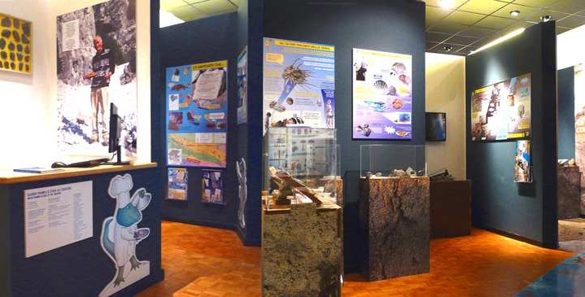

Fig. 1 - View of the entrance to the permanent exhibition When Pramollo was at the Equator. In the background, four of the six panels dedicated to the large groups of organisms that once thrived in the Carnic Alps.

Secondly, it must be able to enhance the public’s knowledge of a subject, reinforcing at the same time the viewers’ perception that the topics they are exploring can be thoroughly understood. This key prerequisite in science communication has been defined information sustainability by Pasquaré Mariotto and Venturini (2017).
Finally, any museum exhibition should be able to generate further interest in visitors, encouraging them to expand, on their own, their knowledge of the topics covered by the exhibition. These three requirements can be summarized in the 3I: Intrigue, Inform, Involve.
If compared to other, Earth Science related exhibitions in Italy, the presently-documented one benefits from an innovative approach based on a) interpretive panels with graphics and texts laid out according to carefully planned strategies; b) interactive and multimedia strategies and tools; c) integration of geological (paleoenvironments) and paleontological (fossils and imprints) contents.
This work is a follow-up to a previous one by Pasquaré Mariotto and Venturini (2017), that proposed a number of strategies aimed at improving Earth Science popularization at museums. The Authors suggested using a novel Earth Science framework (Fig. 2), designed to help put geological science in context.
We need to underscore that our attempt is one among others, which have been aimed at defining and applying geological frameworks to various Earth Science disciplines: In this context, it is particularly worth citing the global framework for geological heritage provided in the milestone work by Dingwall et al. (2005) and more recently, by another major paper (van Wyk de Vries et al. 2017).
The main goal of the present work, more limited in extent, is to demonstrate the application of the Earth History framework and the strategies put forward by Pasquaré Mariotto and Venturini (2017), to a geoscience exhibition dedicated to promoting geoheritage in a well-known area of the Italian Alps.

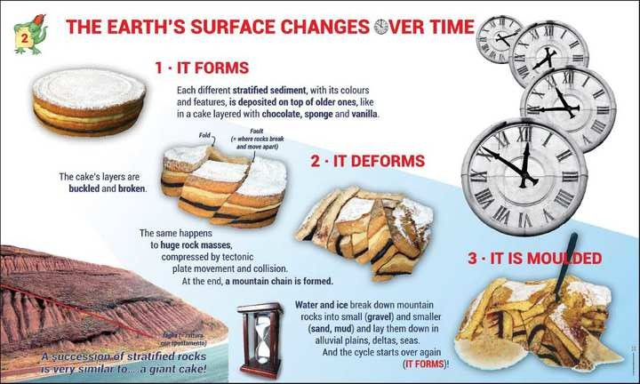

Fig. 2 - Example of a large-sized interpretive panel, designed to illustrate the Earth history framework proposed by Pasquaré Mariotto and Venturini (2017). It is worth observing the comparison between stratified rocks and a familiar object, such as a cake.

Overview of the exhibition

The exhibition – about 90 linear meters - stretches across two separate halls that help the visitor take in the contents in sequential order. The elements upon which the exhibition was structured are: interactive and multimedia exhibits, interpretive panels and several, outstand-ing fossil samples. In planning the museum exhibition, great care was taken to: a) design a sequential path, from the transmission of basic Earth Science topics (in the first hall), to the appearance of the region in Paoelozoic times (in the second hall); b) create a “downhill-progressing conceptual pathway” from the first hall, more intellectually challenging for viewers, to the second hall, that requires a lesser degree of concentration.
The above goals were accomplished by carefully arranging and distributing intepretive panels, interactive and multimedia exhibits as well as fossil samples and imprints. Reading panels requires more attention and concentration than dealing with interactive exhibits or viewing samples. Therefore, in this exhibition the ratio between explanatory panels and multimedia exhibits decreases from the first hall to the second one.
In particular, as most visitors lack a basic knowledge of the processes that guide the geological evolution of an area, the first hall was designed to enable them to achieve a basic “geological literacy”. Considerable care was taken to introduce key concepts such as geological time and the age of rocks, with particular regard to the Pramollo area (Fig. 3).

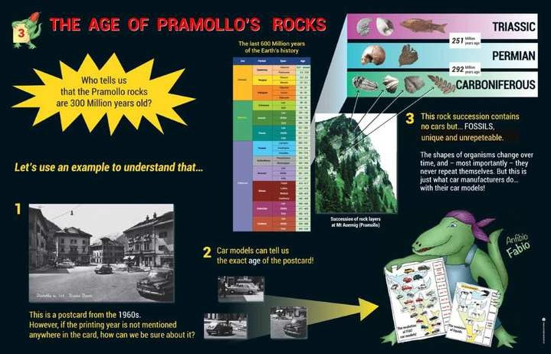

Fig. 3 - A large-sized panel dedicated to the age of Pramollo’s rocks. The exhibition’s mascot (AnfibioFabio) is shown here holding two boards, on which the evolution of the Equidae family over the last 50 million years is compared to the evolution of FIAT car models over the past 100 years.

The large-sized panel displayed in Figure 3 features a 1960s postcard with car models dating back to that time; this is aimed at helping visitors understand the use fossils for age determination and correlation of sedimentary rock layers. Another key concept is the location of continents in the past and its changes over time: To cover this topic in an engaging way, a large-sized panel was designed (Fig. 4) to introduce the basics of plate tectonics by using a comparison with bumper cars on a track.
At the same time, the first hall was designed to show large groups of organisms embedded in the rocks of this area of the Carnic Alps, as well as to valorize their paleontological peculiarities. To achieve the latter goal, a number of selected fossils are displayed on explanatory panels (see Fig. 1), six of which are well known in the worldwide paleonto-logical community (Kahler and Kahler 1982; Fritz et al. 1990; Flügel et al. 1997; Fritz and Krainer 2007; Baucon and de Carvalho 2008).

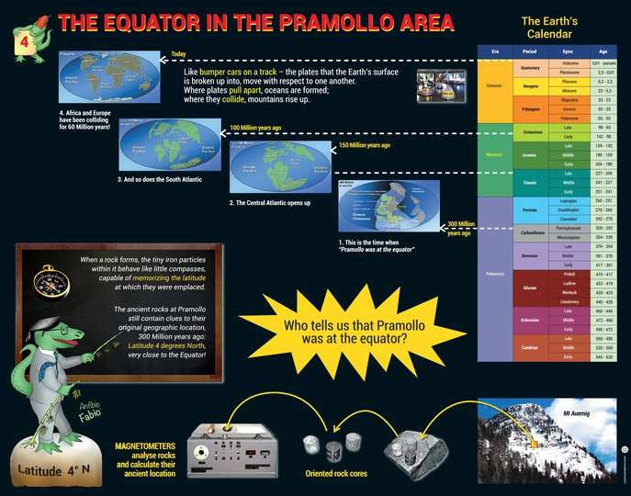

Fig. 4 - A large-sized panel in the first hall, designed to provide details on the equatorial location of the Pramollo area during Carboniferous times. Once again, the exhibition’s mascot is shown, teaching the basics of paleomagnetism.

The second hall plays the role of immersing the visitor into Carboniferous habitats – deltaic areas as well as seafloors – by describing the fossil groups that thrived in those paleoenvironments, as well as going over their features and explaining the reasons for their diffusion. An asset of this part of the exhibition is that visitors can physically handle the fossils, either continental (mailly plant fossils) or marine.
Moreover, they can zoom in on plant fossils (Fig. 5) by means of a microscope mounted on a movable counter. At the same time, zoomed-in details appear on a nearby mini- screen. The interactive exhibits displayed across this hall have been planned for younger, school- age visitors, a sector of the museum audience that needs to be engaged, so as to make their learning experience more effective.
Moreover, an exhibition mascot (the AnfibioFabio,“Fabius the Amphibian”) has been created especially for younger visitors (see Fig. 3 and Fig. 4), with the purpose of conveying some of the topics covered by the exhibition in a more friendly manner. The choice of the AnfibioFabio derives from the discovery of a fossil imprint in the sedimentary layers of the Pramollo area; the imprint represents the oldest impression of a terrestrial vertebrate ever found in Italy (Mietto et al. 1985).
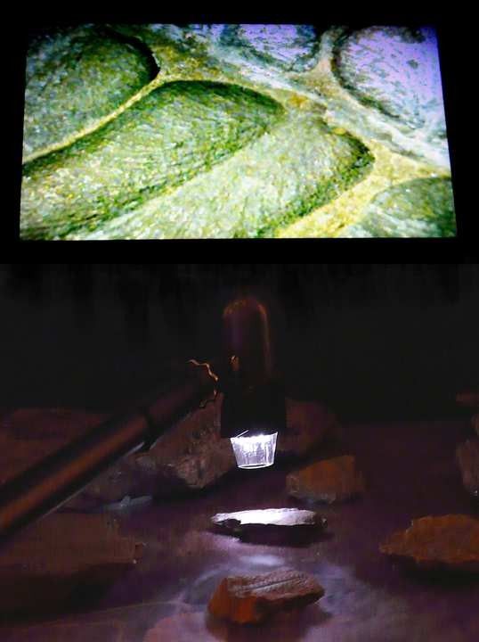
The large amphibian that left this imprint on ancient sand deposits belongs to the genus Eryops; it was probably about 1.2 m long and might have weighed more than 50 kg (Venturini 2016). For comparison, the oldest remains of a terrestrial vertebrate was found in the United States, and dates back the Late Devonian (Rainer 2014).

Fig. 5 - A hands-on exhibit in the second hall: here, the visitors can use a microscope for zooming in on plant fossils.

3. Interactivity and multimedia at the exhibition
In recent years, increasing emphasis has been placed on the use of digital technologies applied to the promotion and management of geoheritage and geosites (Cayla 2014; Cayla et al. 2014; Ghiraldi et al. 2014; Hoblea et al. 2014; Ravanel et al. 2014). Tools such as web mapping (Martin et al. 2014), 3D web-based navigation (Martínez-Graña et al. 2014; Aldighieri et al. 2016), Unmanned Aerial Vehicle (UAV)-assisted technology (Fernández-Lozano and Gutiérrez-Alonso 2017) are being increasingly used to characterize and promote geoheritage and geosites.
As underlined by Martin (2014), interactivity and multimedia can be used to improve the interpretation of geosites and geoheritage. In this respect, also graphic and animated media (Lansigu et al. 2014) have been suggested as valuable tools for geoheritage interpretation and promotion. Moreover, Rapprich et al. (2017) have highlighted the importance of 3D anim-ations and augmented reality in enhancing the public’s understanding of volcanic processes and geoheritage.
In the museum environment, interactive and multimedia exhibits (as defined in Alfonso and Gilbert 2007) can play a key role in attracting younger visitors. In planning the exhibition dedicated to the Pramollo geoheritage, particular care was taken to combine innovative interpretive panels with cutting-edge interactive and multimedia exhibits, three of which were set up in the first hall and five in the second one.
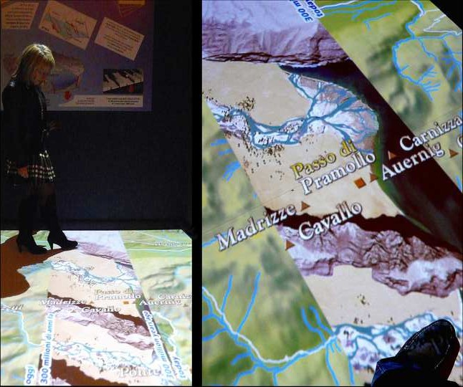
Since it is not feasible to illustrate the whole interactive and multimedia contents that are featured in the exhibition, hereunder is provided a brief description of a few selected exhibits: For example, across the floor of the first hall is screened the present-day topographic map of the Pramollo area. As visitors walk on the map (Fig. 6), they can observe how present-day sites looked like in the Late Carboniferous, 300 million years ago.
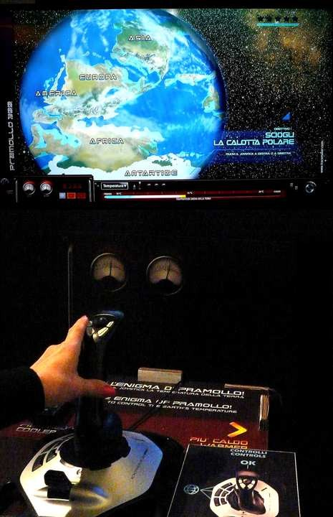

Fig. 6 - One of the interactive strategies placed in the first hall, designed to enable visitors to appreciate the appearance of the Pramollo area in Carboniferous times.

Fig. 7 - Interactive exhibit intended to showing the relations between global temperature, ice cover and sea-level change in the Carboniferous. Right of the screen is a 3D column (not framed in the picture), highlighting different sedimentary layers that form in different sea-level and water depth conditions.

It is worth mentioning another exhibit available to visitors in the first hall: Here, the average Earth’s temperature can be manually modified by means of a joystick (Fig. 7); by increasing or decreasing the Earth’s temperature, the visitors can explore the effects of temperature change over the worldwide ice cover in the Carboniferous, as well as the relevant impacts on ancient sea-level and coastline change. At the same time, a 3D column helps dynamically visualize the formation and superimposition of different types of sediments in the Pramollo area, tightly related to the variations in climate and water depth in the Late Carboniferous.
On the other hand, the multimedia and interactive experiences in the second hall were developed to help visitors understand the features of ancient organisms as well as their living environments. This arrangement of interactive exhibits is in agreement with the pattern of the public’s attention: This is usually at its best at the beginning of the museum experience, but it may progressively dwindle later on (Serrel 1997; 1998).
Here, two large screens have been installed, aimed at immersing the visitors in ancient continental and marine environments, and providing them with a visual window onto the appearance of a “world” that disappeared 300 million years ago. As shown in Fig. 8, a large screen placed in the second hall is designed to dynamically recreate onshore (fluvial and marshy) environments, as well as the flora and fauna that once populated the area.
When visitors walk by the screen, a number of sensors instantly set the amphibians and a Meganeura (giant dragonfly) in motion. At the same, time, all relevant information about the displayed Carboniferous creatures pop-up on screen.

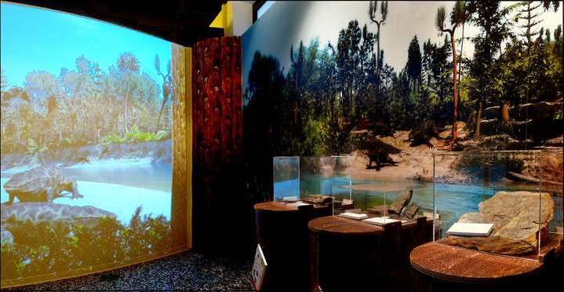

Fig. 8 - One of the two large screens placed in the second hall. The large screen is adjacent to a large diorama, at the front of which are display cases containing Carboniferous fossils.

Applying the global framework to an Earth Science exhibition
The permanent exhibition When Pramollo was at the Equator (Venturini 2016) may be regarded as an application of the strategies put forward by Pasquaré Mariotto and Venturini (2017), both in terms of multimedia strategies and of the production of effective interpretive panels. The previous chapter was dedicated to providing an overview of the interactive and multimedia contents of the exhibition.
Here, we focus on interpretive panels, which can be effectively used both outdoor, i.e. in geoparks (e.g. Zu 2010; Cardozo Moreira 2012) and in museum exhibitions dedicated to geoscience and geoheritage (Pasquaré Mariotto and Venturini 2017).
The Pramollo exhibition features 40 interpretive panels, whose graphic layout was planned in agreement with Ekarv (1987), Wolf and Smith (1993), Miles and Tout (1998), Bitgood (2002), Ravelli (2006), Mileham (2006), Fairchild et al. (2007), Miglietta (2011), Venturini and Pasquaré Mariotto (2013) and Venturini (2017). For the sake of brevity, in this chapter we provide a brief description of four out of 40 interpretive panels. The first example is represented by a small-size panel aimed at introducing visitors to the mysterious world of Nautiloids, particular kinds of “living fossils” (Fig. 9).
The texts are kept to a minimum length and are arranged along two vertical lines. The light blue and white backgrounds of the first set of vertical texts are placed underneath the title, so as to suggest the desired reading order. The vertical layout of texts is made less cumbersome by the arrangement of the images, which are aligned along lines that are cross-cutting each other. Moreover, it is worth underscoring the role played by arrows, suitable for aiding the viewer in correctly associating texts and related images.

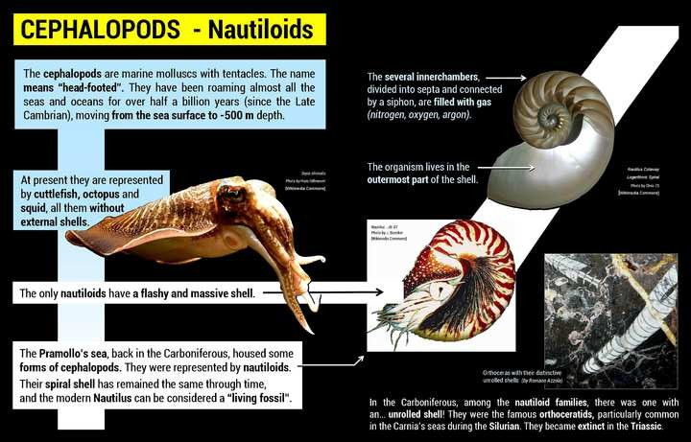

Fig. 9 - Example of a small-sized panel, featuring a description of Nautiloids.

The second example centers on a large-sized panel titled Marine fossils…On mountain tops!, which is featured at the end of the first hall (Fig. 10), and was designed to explain to viewers that, owing to crustal compression, the sedimentary layers were formed on ancient marine floors, together with their fossil assemblages, are lifted up and eventually moulded by surface water and ice.

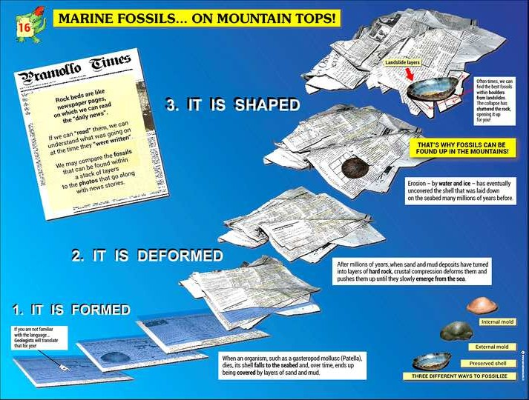

Fig. 10 - Example of a large-sized panel, which displays some of the communication strategies discussed in the text.

First of all, texts ad images are placed along curved, oblique lines. This is one of the graphic strategies that should encourage the viewer to spend some time in front of an explanatory panel, without being turned away from it, such as in the case of panels that featuring texts and graphics arranged along vertical and horizontal lines, resembling textbooks (Pasquaré Mariotto and Venturini 2017). The numbers (1-2-3) are inserted with the purpose of hinting at the correct reading path, which is also suggested by the evolution of the images.
The topic is introduced by way of a newspaper page, whose content attracts viewers and strengthen their involvement. The whole interpretive panel (see Fig. 3) is based on the comparison between “newspaper pages filled with news” vs “sedimentary beds filled with information”. The panel features objects from the everyday’s life and is capable of conveying a key topic, such as the evolution of rocks through geological time, by way of an Earth History framework, or paradigm (it forms, it is deformed, it is moulded) that was first put forward by Venturini (2010) and further discussed in Pasquaré Mariotto and Venturini (2017).
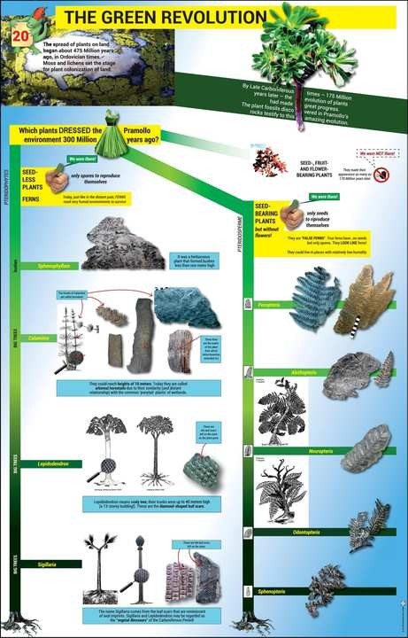

Fig. 11 - Example of a large-size panel that shows most of the graphic layout options for producing
an engaging interpretive panel. Notice also the use of seemingly out-of-context images, aimed at arousing attention and highlighting particular features.

A further example is relative to an interpretive panel displayed in the second hall (Fig. 11), titled The green revolution. This panel is aimed at illustrating the several plant species that dwelled in this region in Late Carboniferous times, and which are documented by the exhibition’s fossil samples. It is particularly worth discussing the appearance of the upper portion of the panel, in order to be able to appreciate the application of most of the strategies put forward by Pasquaré Mariotto and Venturini (2017).
First the title is suitable for capturing the visitor’s attention. The background image hosting the introductory text, which is as brief as possible, is a quartz pebble (colonized by present-day lichens), which belonged to Carboniferous, fluvial and deltaic deposits in the region.
They were illustrated in the first hall and represented, back in those days, the emerged areas that were progressively subjected to the green revolution. The graphic layout, as always is the case, plays a key role. The lower section of the panel is arranged along orthogonal lines. In this case, the wealth of images helps to avoid a “textbook effect” that might discourage viewers. At the same time, this orthogonal arrangement provides a chance to turn the two green, vertical stripes that connect the images into tree trunks (notice the roots at the base of the panel). Such kind of graphic strategy is key to enticing the viewer and, at the same time, it is crucial in order to prevent boredom and reduce the likelihood that visitors are turned away from the panel.
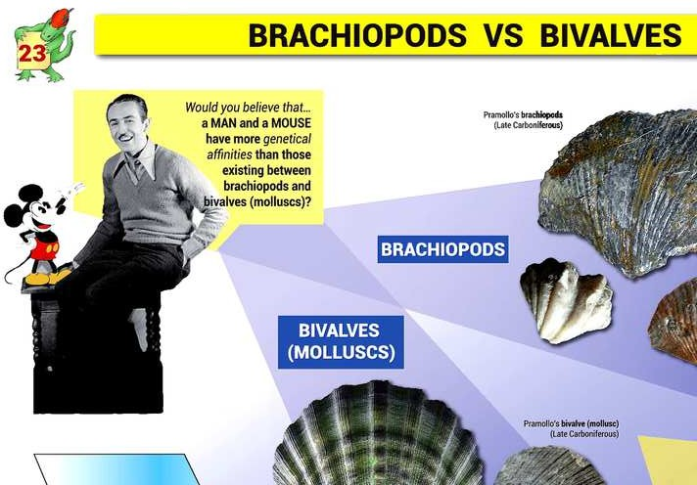
The latter strategy can be mostly observed in the upper section of the panel: In particular, the green ball dress expresses the concept of vegetation that “dresses up” the landscape. The green thumb image is aimed at the highlighting the presence of plant species that had already made their appearance on Earth. Conversely, the well- known, no-trespassing road sign is used to mark plant types (such as Angiospermae) that had not yet appeared on Earth.

Fig. 12 - A detail from a large-sized panel, featuring an effective communication strategy, made possible by the use of two world-famous characters (Walt Disney and his best-known creation), which are functional for highlighting exterior similarities vs genetic differences shown by bivalves and brachiopods.

Similar strategies were used in producing other interpretive panels in the exhibition: As can be observed (Fig. 12), “unusual” images can be used to convey complicated concepts in a visitor- friendly fashion.
In the interpretive panel of Figure 12, the image of Walt Disney and Mickey Mouse was inserted to introduce the concept that a similar exterior appearance does not necessarily reflect genetic affinity; for instance, bivalves and brachiopods, which were widespread in the Pramollo area, look very similar but are genetically quite different.
Finally, we evaluated a great number of replies to a 9-item questionnaire, which was handed out to visitors at the exhibition: We oberved that 81% of the young students attending middle high schools (11-to-14) did not experience any difficulties understanding the scientific information displayed on interpretive panels. 16.6% of the visitors reported some difficulties and only 2.4% reported major difficulties.
Moreover, 76% of 11-14 year old visitors declared, as a result of the visit, an increase in their awareness of the importance of preserving geoheritage and the natural habitat. This is, in our opinion, a demonstration that a science-based exhibition can stimulate the younger generation to develop a deeper understanding of, and respect for, the environment in which they live.

Conclusive remarks

We do believe that this exhibition has been able to accomplish its primary goals, thanks to its diversification and capacity to match different interests. The latter goal has been achieved by designing the exhibition around three main aspects: interactive and multimedia tools, fossil samples and, last but not least, interpretive panels, which can be a fundamental tool to maximize the museum experience but, to this day, at least in Italy, they often represent an obstacle to information sustainability.
This is mainly due to the lack of communication strategies, to major flaws in the panels’ graphic layout and, most of all, due to the use of long, cumbersome texts, often arranged along orthogonal lines so as to resemble the pages of a textbook, something that would turn any visitor away from the subject of an exhibition.
The winning strategy for attracting the middle-to-high-school age group has consisted in combining interactive and multimedia contents with traditional ones: The former have been the key to engaging the younger visitors, enabling them to effortlessly delve into geoscience-related topics.
We also hope this exhibition has been instrumental in raising the visitors’ awareness about the importance of knowing, promoting and preserving geoheritage, the safeguard of which is paramount to ensuring a livable planet for mankind.

Acknowledgments
We are extremely grateful to Vladislav Rapprich for his thorough and insightful review, which has enabled us to substantially improve the overall quality of our work. A. Baucon is fully acknowledged for designing the software that resulted in the creation of all multimedia installations featured in the exhibition. We would like to thank the Municipality of Pontebba for making the exhibition possible through a project, co-financed by the European Union.

References

Aldighieri B, Testa B, Bertini A (2016) 3D Exploration of the San Lucano Valley: Virtual Geo- routes for Everyone Who Would Like to Understand the Landscape of the Dolomites. Geoheritage 8:77–90.
Alfonso A, Gilbert J (2007) Educational value of different types of exhibits in an interactive science and technology center. Science Education 91: 967–987.
Ávila SP, Cachão M, Ramalho RS Botelho AZ, Madeira P, Rebelo AC, Cordeiro R, Melo C, Hipólito A, Ventura MA, Lipps JH (2016) The Palaeontological Heritage of Santa Maria Island (Azores: NE Atlantic): a Re-evaluation of Geosites in GeoPark Azores and Their Use in Geotourism. Geoheritage 8:155-171.
Baucon A, de Carvalho CN (2008) From the river to the sea: Pramollo, a new ichnolager-stätte from the Carnic Alps (Carboniferous, Italy-Austria). St. Trent. Sci. Nat. Acta Geol. 83:87-114.
Baucon A, Venturini C, Neto de Carvalho C, Muttoni G (2015) Behaviors mapped by new geogra- phies: Ichnonetwork analysis of the Val Dolce Formation (lower Permian; Italy-Austria). Geosphere 11: 744-776.
Bitgood S (2002) Environmental psychology in museums, zoos, and other exhibition centers. In Bechtel R and Churchman A (Eds) Handbook of Environmental Psychology. Wiley, New York, 461-480.
Brocx M, Semeniuk V (2007) Geoheritage and geoconservation - history, definition, scope and scale. Journal of the Royal Society of Western Australia 90:53–87.
Brocx M, Semeniuk V (2010) Coastal geoheritage: a hierarchical approach to classifying coastal types as a basis for identifying geodiversity and sites of significance in Western Australia. Journal of the Royal Society of Western Australia 93:81–113.
Brocx M, Semeniuk V (2011) The global geoheritage significance of the Kimberley Coast, Western Australia. Journal of the Royal Society of Western Australia 94:57–88.
Cardozo Moreira J (2012) Interpretive Panels About the Geological Heritage - a Case Study at the Iguassu Falls National Park (Brazil). Geoheritage 4:127–137.
Cayla N (2014) An overview of new technologies applied to the management of geoheritage. Geoheritage 6:91–102.
Cayla N, Hobléa F, Reynard E (2014) New digital technologies applied to the management of geoheritage. Geoheritage 6:89–90.
de Grosbois AM, Eder W (2008) Geoparks - a Tool for Education, Conservation and Recreation. Environmental Geology 55:465-466.
Dingwall P, Weighell T, Badman T (2005) Geological World Heritage: a global framework. A con- tribution to the global theme study of World Heritage natural sites, Protected Area Programme. IUCN, Gland, Switzerland.
Ebner F, Kahler F (1989) Catalogus fossilium Austriae. Foraminifera palaeozoica, II/b/1, Osterr. Akad. der Wissenschaften, 296 pp.
Ekarv M (1987) Combating redundancy: writing texts for exhibitions. In E.Hooper-Greenhill (Cura- tor), The educational role of the museum (2nd ed.; 201-204). London, UK and New York, NY: Routledge.
Fairchild A, Charlebois C, Freed T (2007) Xi’an. A study of an exhibition. In Nardi E (ed) Pensare, valutare, ri-pensare. La mediazione culturale nei musei. Franco Angeli Editore, Milan, Italy.
Fernández-Lozano J, Gutiérrez-Alonso G (2017) The Alejico Carboniferous Forest: a 3D-Terrestrial and UAV-Assisted Photogrammetric Model for Geologic Heritage Preservation. Geoheritage 9:163.
Flügel E, Fohrer B, Forke H, Krainer K, Samankassou E (1997) Cyclic sediments and algal mounds in the Upper Paleozoic of the Carnic Alps. Gaea Heidelbergensis, 18° I.A.S. Reg. Europ. Meeting, Heidelberg 1997 4:79-100.
Fritz A, Boersma M, Krainer K (1990) Pflanzen fossilien aus Kärnten. Carinthia II, 49, 190 pp.
Fritz A, Krainer K (2007) Vegetationsgeschichtliche und florenstratigraphische Untersuchungen im Oberkarbon und Unterperm der Ost- und Sudalpen (Teil 2). Carinthia II 197/117:91-148.
Ghiraldi L, Giordano E, Perotti L, Giardino M (2014) Digital tools for collection, promotion and visualisation of geoscientific data: case study of Seguret Valley (Piemonte, NW Italy). Geoheritage 6:103–112.
Hoblea F, Delannoy J-J, Jaillet S, Ployon E, Sadier B (2014) Digital Tools for Managing and Pro- moting Karst Geosites in Southeast France. Geoheritage 6:113–127.
Kahler F, Kahler G (1982) Ober-karbonische Fusuliniden der Karnischen Alpen. Palaeontographica 177A:89-128.
Lansigu C, Bosse-Lansigu V, Le Hebel F (2014) Tools and methods used to represent geological processes and geosites: graphic and animated media as a means to popularize the scientific content and value of geoheritage. Geoheritage 6:159–168.
Martin S (2014) Interactive visual media for geomorphological heritage interpretation. Theoretical Approach and Examples. Geoheritage 6:149–157.
Martin S, Reynard E, Pellittero Ondicol R, Ghiraldi L (2014) Multi-scale web mapping for geoher- itage. Visualisation and Promotion. Geoheritage 6:141–148.
Martínez-Graña A, González-Delgado JA, Pallarés S, Goy JL, Civis Llovera J (2014) 3D Virtual Itinerary for Education Using Google Earth as a Tool for the Recovery of the Geological Heritage of Natural Areas: Application in the “Las Batuecas Valley” Nature Park (Salamanca, Spain). Sus- tainability 6:8567-8591.
Melinte-Dobrinescu MC, Brustur T, Jipa D, Macalet R, Ion G, Ion E, Popa A, Briceag A (2017) The Geological and Palaeontological Heritage of the Buzău Land Geopark (Carpathians, Romania). Geoheritage doi:10.1007/s12371-016-0202-3.
Mietto P, Muscio G, Venturini C (1985) Impronte di Tetrapodi nei terreni carboniferi delle Alpi Carniche. Gortania, Atti Mus. Friul. St. Nat 7:37-58.
Miglietta AM, Pace R, Boero F (2011) Evaluating Students’ Comprehension of Messages on Pan- els. Visitor Studies 14:209-218.
Mileham R (2006) Wise words. Museums Journal 106:18-19.
Miles R, Tout A (1998) Divulgare la scienza attraverso le esposizioni. CLUEB, Bologna, Italy.
Pasquaré Mariotto F, Venturini C (2017) Strategies and Tools for Improving Earth Science Education and Popularization in Museums. Geoheritage 9:187-194.
Rapprich V, Lisec M, Fiferna P, Závada P (2017) Application of Modern Technologies in Popular- ization of the Czech Volcanic Geoheritage. Geoheritage 9: 413-420.
Rainer RS (2014) Amphibian Evolution: The Life of Early Land Vertebrates. Topics in Paleobiology. Wiley Blackwell, 280 pp.
Ravanel L, Bodin X, Deline P (2014) Using Terrestrial Laser Scanning for the Recognition and Promotion of High-Alpine Geomorphosites. Geoheritage 6:129–140.
Ravelli LJ (2006) Museum texts: communication frameworks. London and New York, NY. Routledge.
Reis J, Póvoas L, Barriga FJAS, Lopes C (2014) Science Education in a Museum: Enhancing
Earth Sciences Literacy as a Way to Enhance Public Awareness of Geological Heritage. Geoherit- age 6:217-223.
Serrell B (1997) Paying Attention: the Duration and Allocation of Visitors’ Time in Museum Exhi- bitions. Curator 40:108–125.
Serrell B (1998) Paying Attention: Visitors and Museum Exhibitions. American Association of Mu- seums: Washington DC.
Thomas M (2016) New keywords in the geosciences - Some conceptual and scientific issues. Revista do Instituto Geologico 37:1-12.
van Wyk de Vries B, Byrne P, Delcamp A, Einarson P, Göğüş O, Guilbaud M-N, Hagos M, Harangi S, Jerram D, Matenco L, Mossoux S, Nemeth K, Maghsoudi M, Petronis MS, Rapprich V, Rose WI, Vye E (2017) A global framework for the Earth: putting geological sciences in context. Global and Planetary Change. https://doi.org/10.1016/j.gloplacha.2017.12.019.
Venturini C (2016) Ti mostro la mostra: Quando Pramollo stava all’equatore. Catalogo e guida della Mostra. Comune di Pontebba (UD), Alea Ed., 192 pp.
Venturini C, Pasquaré Mariotto F (2013) Strategie di comunicazione delle Scienze della Terra. Nuova Museologia 29:38-44.
Wolf L, Smith J (1993) What makes museum labels legible? Curator 36:95-110.
Xu K (2010) Tourist satisfaction of interpretation panels: a case study of Baili Canyon, Fanshan Global Geopark of China. In: UNESCO International Conference on Geoparks, 4. UNESCO, Langkawi, 94.

